Template for Report

Author 1, Author 2

1. INTRODUCTION

In this section, a general description of the problem under consideration is provided. As soon as the reader completes reading the introduction, (s)he should be aware of what will be discussed in the main body and the possible contributions, e.g., how the problem is solved. It is suggested to briefly describe, in words, the structure of the report and how it is organized. The report could be single or double column.

1. PROBLEM FORMULATION AND SOLUTION

This section contains the analytical presentation of the problem and the solution steps. It could be organized in many different subsections, depending on the structure of the problem itself (one central problem or several small tasks) and the author’s personal choice of presentation.

* 1. Part 1

The first part of the problem along with its solution goes here. It is suggested to number any equations that will be referenced later in text.



The above equation is referred to as Eq. or , anywhere the text.

1. Part 2

The report continues with the second part, and so on until the whole problem has been addressed and solved. If someone wants to refer, at some point, to external material then proper citation and referencing is needed, e.g., the coursebook in signal theory [1]. Figures and images are placed at the top/bottom of the page to avoid interrupting the text flow. In the text we refer to a figure as Figure 1. Remember to be consistent with your references, i.e., do not use both Eq. and .

1. CONCLUSIONS

A summary of the findings is provided here. It is also good to highlight the most important parts of the solution and briefly discuss some implications, e.g. in real-world applications, or extensions deserving further investigation.

REFERENCES

1. P. Handel, R. Ottoson, H. Hjalmarsson, Signal Theory, KTH, 2012

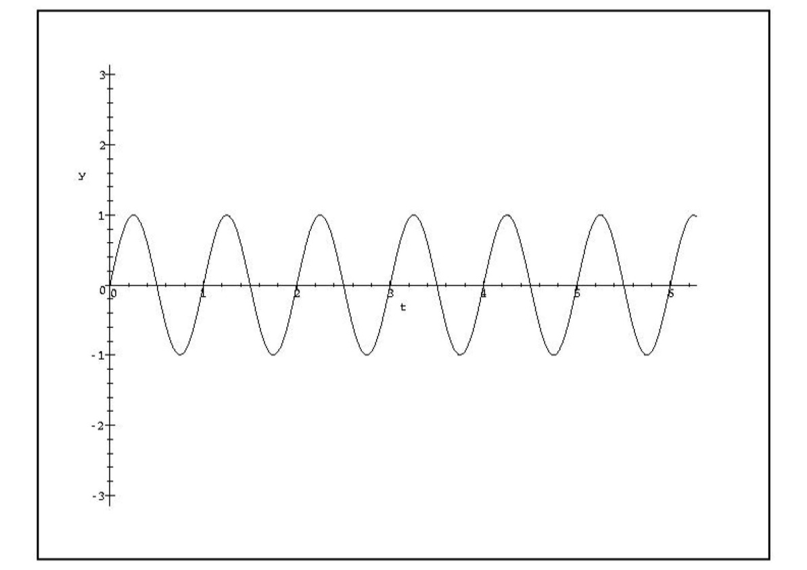

Figure 1:Sample figure.